system desgin

system : collection of technology which server sets of users to full fill their requirement

design : artitecture of that system based on the users requriement which serveses people to full fill theire requirement

system desgin : is process of understanding users requirement and artituce a sytem based on those requirement to serve people to full fill their requirement

component of system design :

i) artitutal design

ii)logical desgin

iii)physical design

above are heigh leve design

why system design ?

we need system design because :

i)to make our application reilable (like our application not down , falult tolerant and consistent)

ii)to make our our application effective (to meet business requirement)

iii)to make our system maintainable (to make our system scalable, like we should be able to do scale up and scale down suppose right now i have 100 active user which are useing my application but what happened when 1000 people are useing my application)

Scalaliblity : suppose right now i have application which have 1000 active user but suppose suddenly i have 1000 user satarted useing my application on regular basis so our application should be scalable to that new user without slowing down like it should be resposnive for the new user with the same speed that is calledd scalebility .

scaleibility is directly propertional to the perfromance of our application

vertical scalling : buying bigger machine

horzinatal scaling : buying more machine

horzantal scaling is also known as homogenous scaling

functional scaling : scaling at the functional level

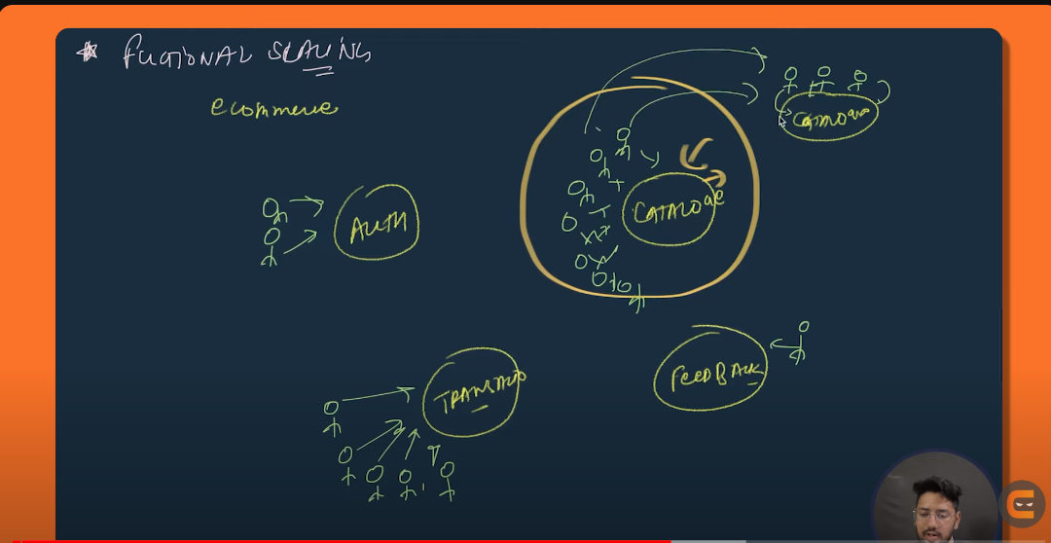

sharding : equally separating the database into some partation it is like a horzintal scaling

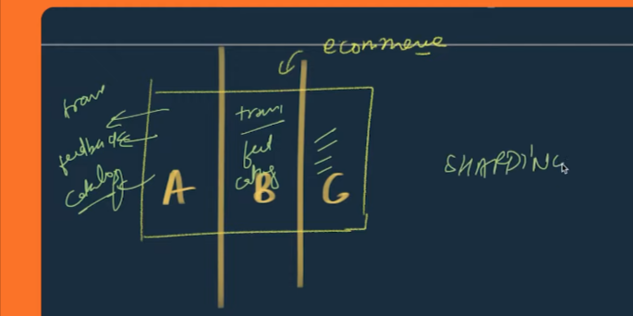

diffrence between horzintal scaling and vertical scaling

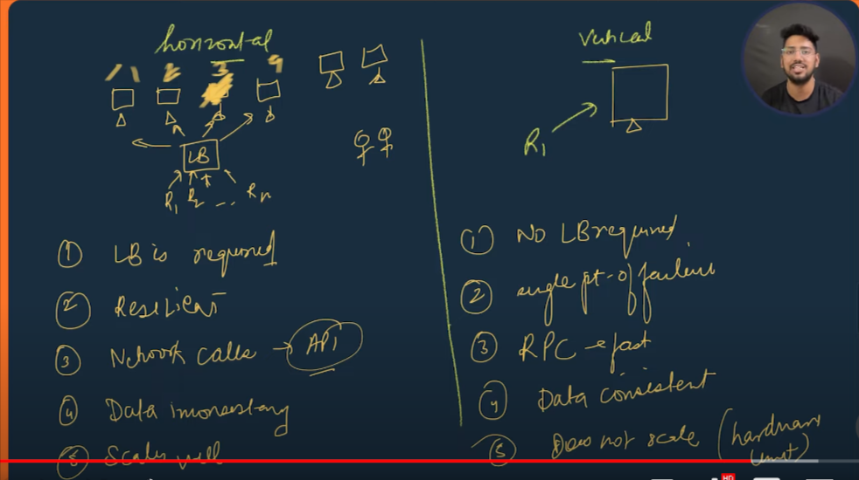

2. lb:load balancer

3. if any of our machine get falult we can migrate the request to other machine so horzintal scalling is resilent and vertical scaling is single point of failure

4. rpc : remote procedure calling (calling at application level )

note : in real word we use mixter of horzintal and vertical scaling

diffrence between performance issue and scalibility issue :



Disturubited cache

in short : cache minimize the operatonal latency by :

i)reduce the no fo network call

ii)reduce Db load

in application we have :

i)cilent side

ii)server side

iii)data base

in normal circumstances our application works fine , but when the no of users incerease there will be increase in no of request on database,internal qurey so there will increase in load on the application which reduces the performance of the application .

In order to keep the perfomrance of our applicaiton we use chahe to reduce the detoratation of the perfomrance of the application .

Q. why not to store everthing in cache ?

i) because there will be increase in serach space (like we will going to have so much data to search upon) so there will be heigh operatonal cost

ii)the hardware that used in cache is very expensive

Polices of caching :

i)LRU caching

ii)LFU caches

Poor evichens polices :

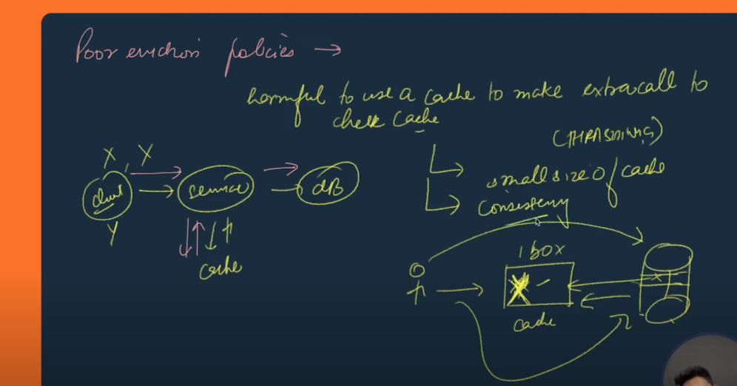

How to update data in distrubted cache ?

i)WRITE THROW CACHE

ii) WRITE BACK CACHE

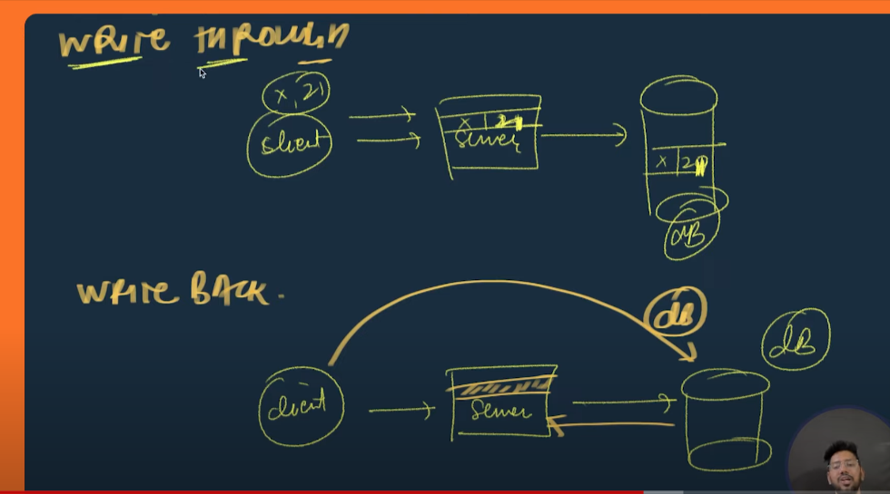

Problem with the write TROW AND WRITE BACK :

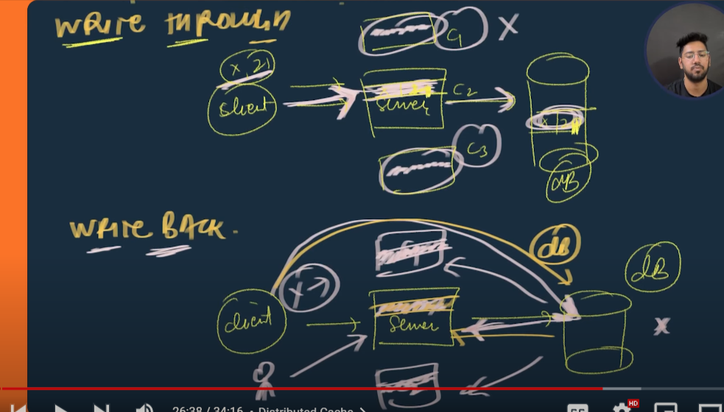

where to place cache :

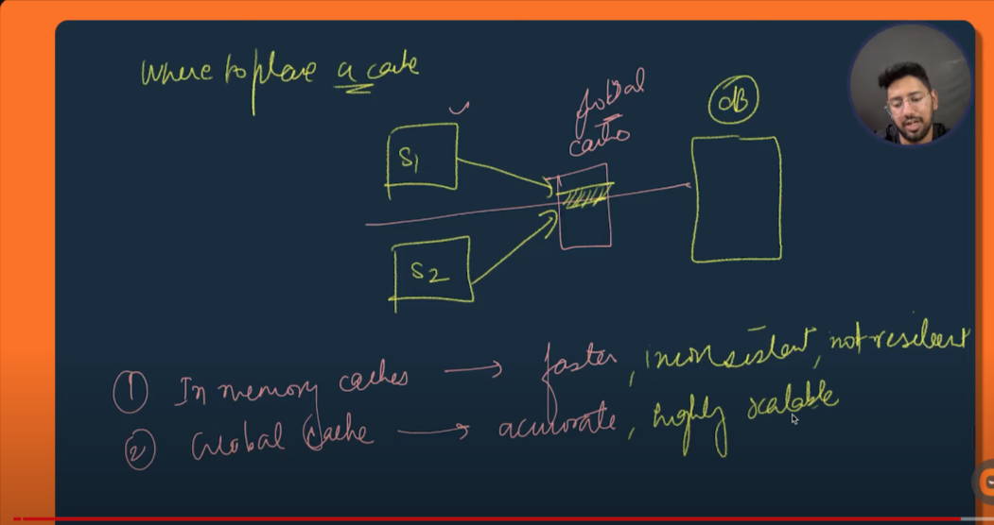

DataBase Sharding :

i) it is optimization technique which performance of our system

ii) it optimizes database performance at a very large scale

options through which we can improve the performance of our application :

i)scalling hardware (but it has some limitation like at after some point we will not be able to increase the limit of our hardware)

ii)add read replica (most of the time we observe that there are much request to read the data than the write the data like instagram)

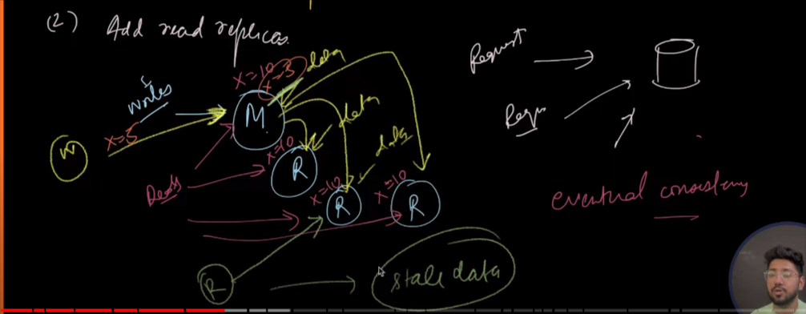

disadvantages : problem of eventual consistency

SHARDING : method of distrubuting data across multiple machine , it occur at database level

PARTATIONING : spliting of data withing same instance , it occur at datalevel

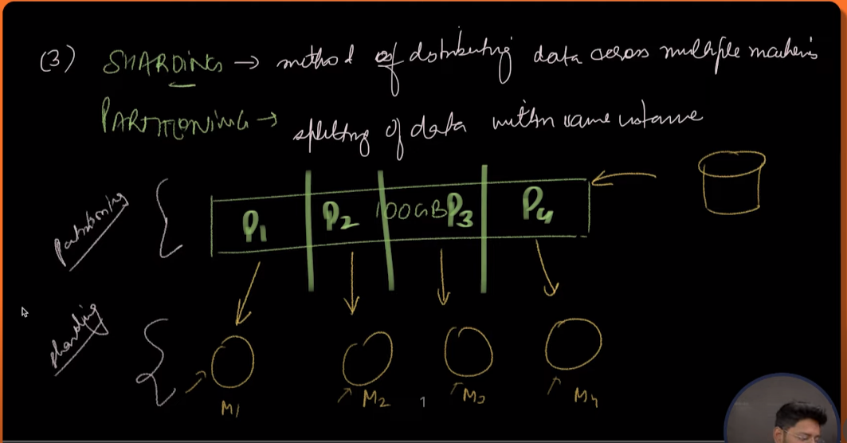

How sharding occur :

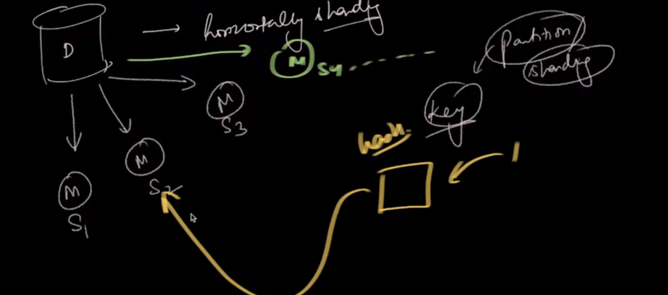

partationing :

i)vertical partationing : spliting on the basis of column

drawbacks : it is less reliable

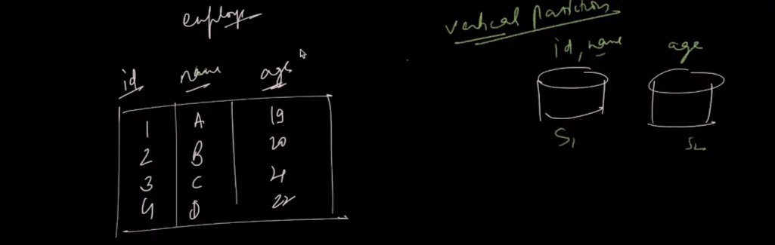

ii)Horizintal partationing :

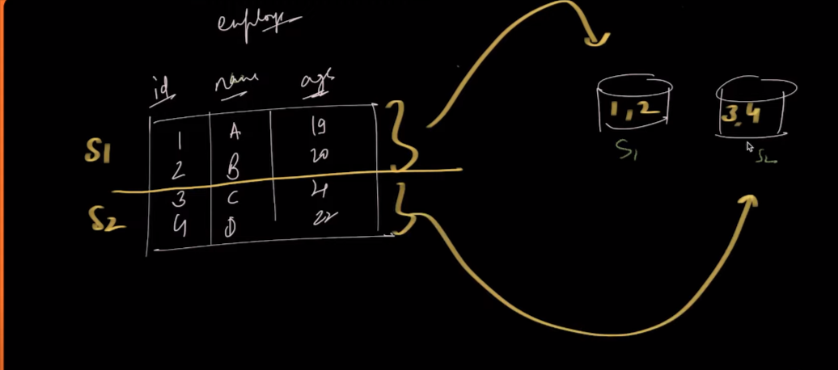

LOGICAL SHARD VS PHYSICAL SHARD :

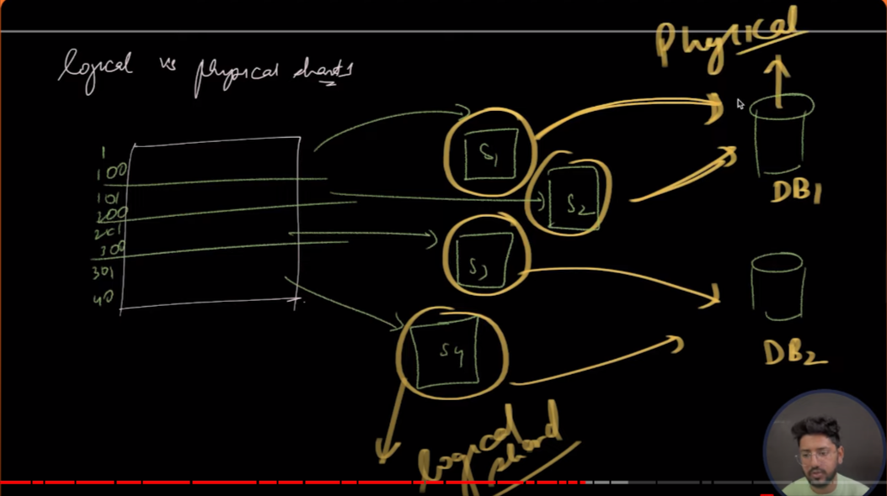

ALOGRITHMIC SHARDING AND DYNAMIC SHARDING :

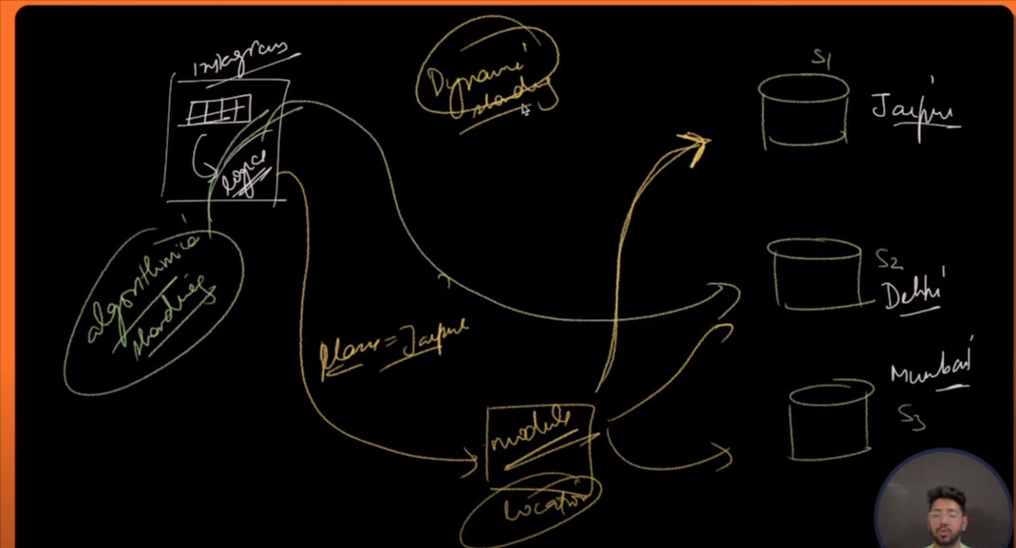

pros and cons of SHARDING :

pros –

a)scalability ( with the horizonal scaling we are able make our appliciation scalble)

b)avalibility and fault tolerent ( previsouly we only one instace of databse it there will any kind of fault the whole data lost but with the sharding we have multiple instace of database )

cons-

a)complexity :

i) complixity interm of partationing of data and maping

ii)complixity in term of routing of data to diffrent shard

MESSAGE QUEUE : it is intermediate between produce and consumer

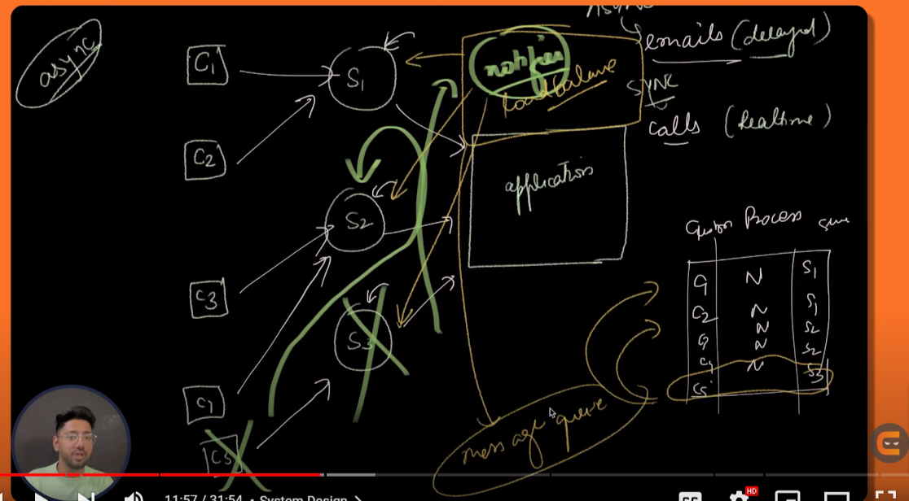

Above thing is called message queue. Ex : domino’s

Advantages of message queue :

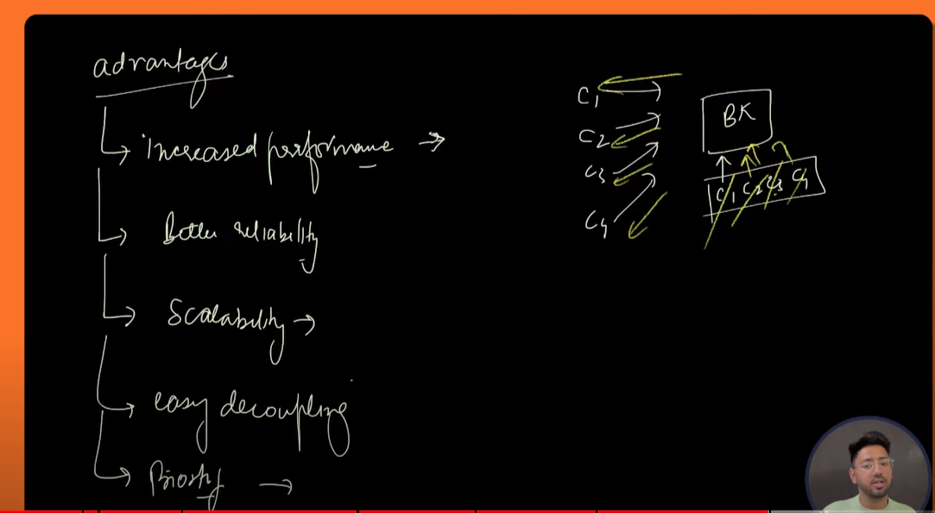

Eg of message queue : AWS , KAFKA